**Objective**

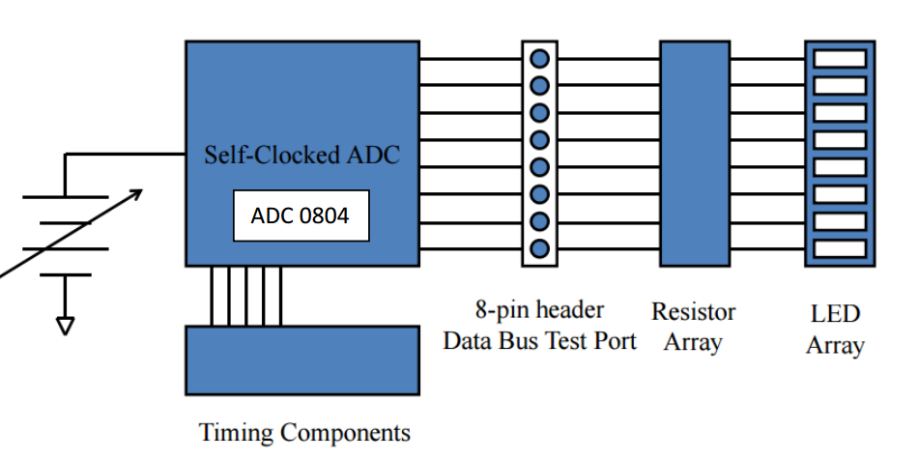The objective of this lab was to build a free-running ADC (analog to digital converter) using the ADC0804. This device will take an analog signal and output that signal in digital form, this intern will help take a human’s voice and save that frequency into ram for recording and back out into a DAC. Figure 1 Shows how the ADC0804 and an array of LEDS will be used in this lab. Throughout this lab certain design decisions needed to be considered and evaluated with the overall project in mind of building an audio device.

**Figure 1.** ADC0804 and LED Array schematic

The Design components considered in this lab was which RC values would be needed, to achieve the correct frequency to sample human speech. The higher the frequency is the higher the quality and the shorter the play back time. While on the other spectrum the lower the frequency the lower quality and longer recoding time for playback.

**Results**

The RC values where calculated in the fallowing manor.

$$fs =\frac{fclk}{CCPS}$$

(2)

$$fs =\frac{800KHz}{73}$$

(3)

$$fs =10.958 KHz$$

Using this design chose the sampling frequency that was found was 10.958 KHz. Which will allow some bandwidth to take aliasing into consideration. The next step was to pick a RC value using this design choose.

(4)

$$fclk=\frac{1}{1.1RC}$$

(5)

$$R =\frac{1}{(1.1)(fclk)(C)}$$

(6)

$$R =\frac{1}{(1.1)(800KHz)(1nF)}$$

(7)

$$R =1.136KΩ$$

The capacitor chosen for this design was 1nF and then used to solve for the R value. The R value that was calculated to be 1.136 KΩ.

(8)

$$Percent Errror=\frac{\left|Actual-Expected\right|}{Expected}*100$$

Using the actual values measured the CCPS was calculated as 67.37089.

(9)

$$CCPS =\frac{fclk}{fs}$$

(10)

$$CCPS =\frac{287KHz}{4.26KHz}$$

(11)

$$CCPS =67.37089$$

The percent error calculation was used to find the error from the actual and the measured values of the components and measured values of the system (Table 1).

**Table 1.** Calculated and actual component and frequency and their percentage error

|  |  |  |  |  |  |
| --- | --- | --- | --- | --- | --- |
|  | R (kΩ) | C (nF) | fs (KHz) | fclk (KHz) | CCPS |
| Calculated | 1.136 | 1 | 10.958 | 800 | 73 |
| Measured | 1.213 | 1.08 | 4.26 | 287 | 67.37089 |
| Percent Error (%) | 6.778169 | 8 | 61.12429 | 64.125 | 7.7111 |

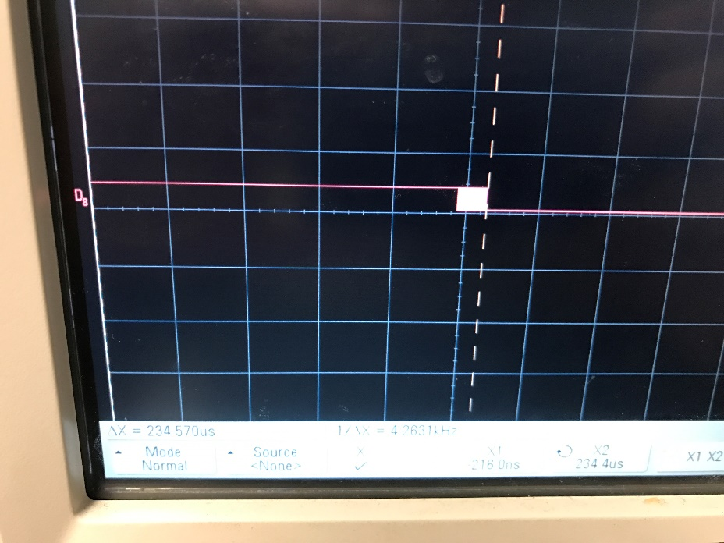

**Figure 2.** Logic Analyzer Output of Channel 8

To check the functionality and accuracy of the ADC. DC input voltage was given to the system and the ADC outputted the digital values on the LED array. Once the values were taken down conversions where done respect to the reference voltage applied of 5V (Table 2).

|  |  |  |  |  |  |  |  |  |  |  |
| --- | --- | --- | --- | --- | --- | --- | --- | --- | --- | --- |
| **Volts Applied (V)** | **1** | **2** | **3** | **4** | **5** | **6** | **7** | **8** | **Volts Converted (V)** | **Percentage**  **Error (%)** |
| **Voltage Resolution per bit (mV)** | 0.019608 | 0.039216 | 0.078431 | 0.156863 | 0.313725 | 0.627451 | 1.254902 | 2.509804 |  |  |
| 0 | 1 | 1 | 1 | 1 | 1 | 1 | 1 | 1 | 0 | 0 |
| 0.33 | 0 | 1 | 1 | 1 | 0 | 1 | 1 | 1 | 0.333333 | 1.010101 |
| 0.66 | 1 | 0 | 1 | 1 | 1 | 0 | 1 | 1 | 0.666667 | 1.010101 |
| 1 | 1 | 1 | 0 | 1 | 0 | 0 | 1 | 1 | 1.019608 | 1.960784 |
| 1.32 | 1 | 1 | 0 | 1 | 1 | 1 | 0 | 1 | 1.333333 | 1.010101 |
| 1.65 | 0 | 1 | 0 | 1 | 0 | 1 | 0 | 1 | 1.666667 | 1.010101 |
| 1.98 | 0 | 0 | 0 | 1 | 1 | 0 | 0 | 1 | 2.019608 | 2.000396 |
| 2.31 | 1 | 1 | 1 | 0 | 0 | 0 | 0 | 1 | 2.352941 | 1.858925 |
| 2.64 | 0 | 1 | 1 | 0 | 1 | 1 | 1 | 0 | 2.686275 | 1.752822 |
| 3 | 1 | 0 | 1 | 0 | 0 | 1 | 1 | 0 | 3.019608 | 0.653595 |
| 3.3 | 0 | 0 | 1 | 0 | 1 | 0 | 1 | 0 | 3.352941 | 1.604278 |
| 3.63 | 1 | 1 | 0 | 0 | 0 | 0 | 1 | 0 | 3.686275 | 1.550262 |
| 3.96 | 1 | 0 | 0 | 0 | 1 | 1 | 0 | 0 | 4.039216 | 2.000396 |
| 4.29 | 1 | 0 | 0 | 0 | 0 | 1 | 0 | 0 | 4.352941 | 1.46716 |
| 4.62 | 1 | 1 | 1 | 1 | 0 | 0 | 0 | 0 | 4.705882 | 1.858925 |
| 5 | 0 | 0 | 0 | 0 | 0 | 0 | 0 | 0 | 5 | 0 |

**Table 2.** DC Bit Conversion accuracy test and percent error

**Explanation**

The usable bandwidth of the human voice is between 300 Hz to 3400 Hz[2]. The highest frequency component in an analog signal determines the bandwidth of that signal. The higher the frequency, the greater the bandwidth. In this case the highest frequency would be the max bandwidth of the human voice which is 3400 Hz. Now when trying to figure out the rate at which this signal should be sampled, the Nyquist Theorem says for a given analog signal the sampling rate is twice that of the max frequency [1]. For our design, we used the max clock frequency at which the ADC0804 can run at to take the limitations of the device into consideration and the other parasitic delays that the board might have.

From the design aspect chosen the RC circuit used to control the internal clock of the ADC0804 used R value of 1.136 kΩ and 1nF capacitor. To achieve the 1.136 kΩ two resistors were put into series, 1.1 kΩ and 36 kΩ. The actual values for both can be seen in Table 1, with a percentage error of 6.778169% and 8 respectively. The experimental sampling frequency was 4.26KHz with a percentage error off about 61.12429%. The clock frequency fclk was measured at 287KHz and had a percentage error 64.125% of both values can be seen in Table 1 as well. This extreme percent error was due to a combination of the tolerances of the components and the parasitic capacitances and resistances the Data Acquisition Board

The DC measurements where used to test the accuracy and resolution for the ADC, which would simulate an analog signal being applied. Table 2 shows the results of the test, the percentage errors of all 15 steps taken never exceeded more than 2%. With a minimal error of 2% percent, the ADC can be said to be accurate enough for audio recording and playback. With the measured values used the actual CCPS of the system was 67.37089CCPS which was 7.7111% off from the expected CCPS of 73 CCPS. Which was due to the overall percentage error of the frequencies measured. Which still will allow for good playback because it is in the threshold of the devices CCPS.

Applying a ramp of 0V to 5V into the system, and using the logic analyzer to detect the INTR signal, the INTR was found to be 234.570 µs. Which translates to 4.26KHz of sampling frequency. The logic analyzer also could show the digital output of the system in real time better than the LEDS could pick up and how the digital system counted correctly.

In all, this experiment was a success. The ADC0804 was successfully placed into free running mode and the RC values help to find an ideal sampling rate for the future project. But, some hurdles need to be kept in mind and faced later. The accuracy of what was calculated and the measured values where off by a great percentage due to design elements that was not in our control. Even though the system was still able to sampling the analog signal with accuracy and the experiment was successful.

**References**

[1]Posted and M. Rouse, "What is Nyquist theorem? - definition from WhatIs.com," WhatIs.com, 1999. [Online]. Available: http://whatis.techtarget.com/definition/Nyquist-Theorem. Accessed: Jan. 21, 2017.

[2]"ATIS telecom glossary," in *atis*, 2017. [Online]. Available: http://www.atis.org/glossary/definition.aspx?id=250. Accessed: Jan. 21, 2017.